**Project Manual : Smart Agriculture Monitoring and Management System**

**Step 1.** Signup yourself.

Once the user create its user id and password he can then login to the system

**Step 2:** login to the system.

Once the user logged in to the system he can then enter his personal details on the registration page.

**Step 3:** Enter the personal details of the farmer

Enter all the details of the farmer, upload the photo of the farmer, then click on the “Save” button to save the data and then click on the “Next Page” button. If there is some mistake in the data entered, then user can click on the “Reset” button, this will remove all the previously entered data and then the user can again enter his/her data.

**Step 4:** Enter the crop details of the farmer.

Now when the user puts all these details than click on the save button and all the details are saved in their respective tables in the database

Now click on the next page and the user will get directed to the dashboard page.

**Step 5 :** Enter Pests details and click on the “Save Pest Data” button.

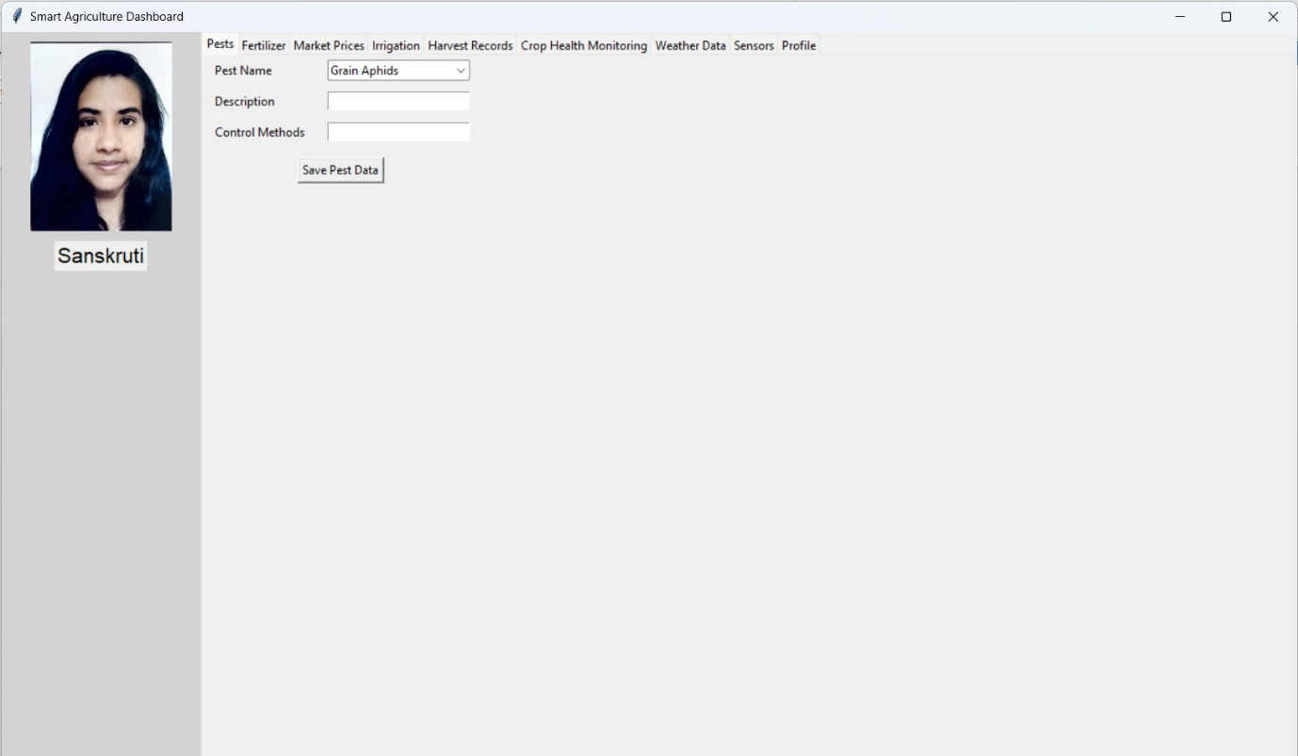

**Step 6 :** Enter Fertilizer details and click on the “Save Fertilizer Data” button.

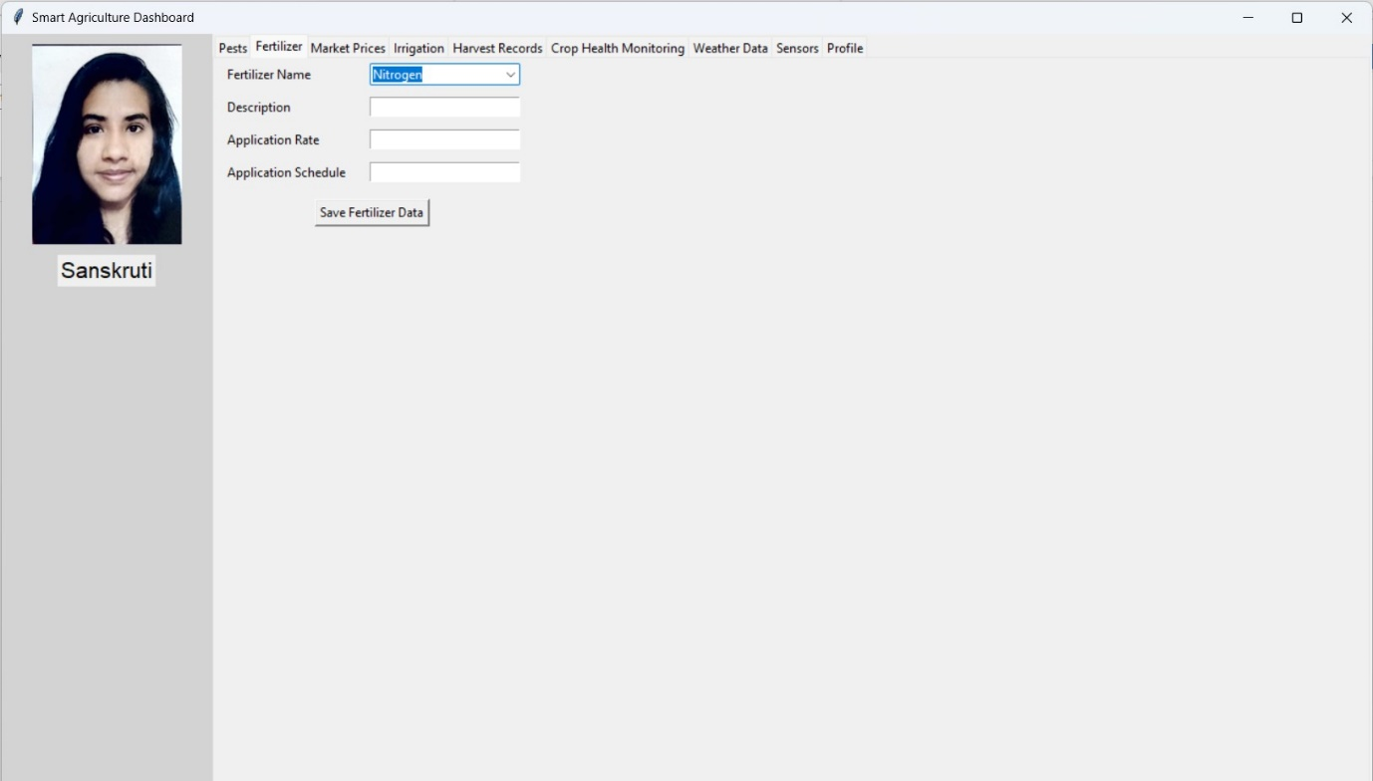

**Step 7 :** Enter Market Prices information and click on the “Save Market Prices Data” button.

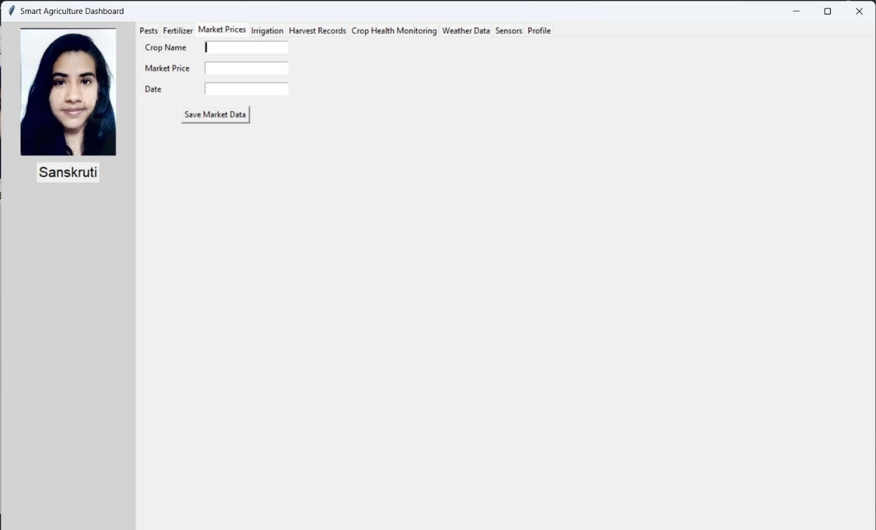

**Step 8 :** Enter Irrigation information and click on the “Save Irrigation” button.

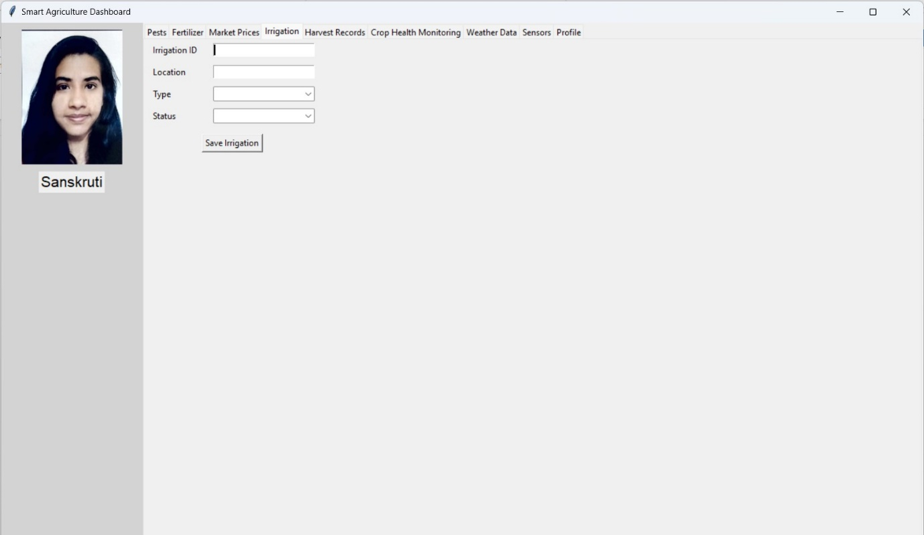

**Step 9 :** Enter Harvest records information and click on the “Save Harvest” button.

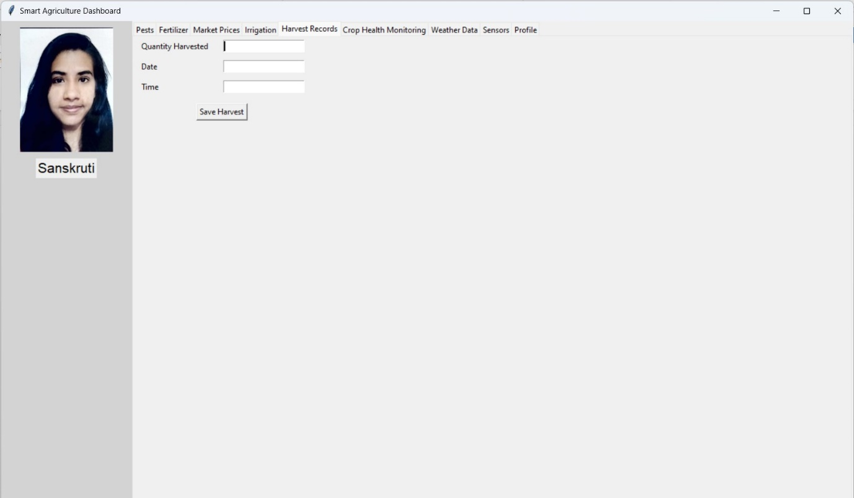

**Step 10 :** In the Sensors Tab, the data of Sensors gets displayed.

* Click on the “Load Data” Button, to see the data in the table form.

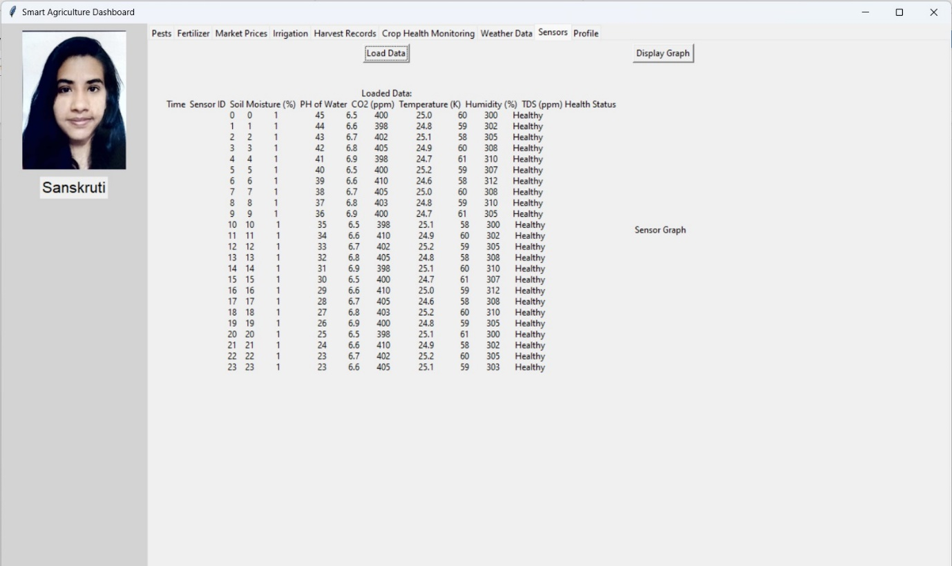

* Click on the “Display Graph” button to see the sensor’s data in the graph format.

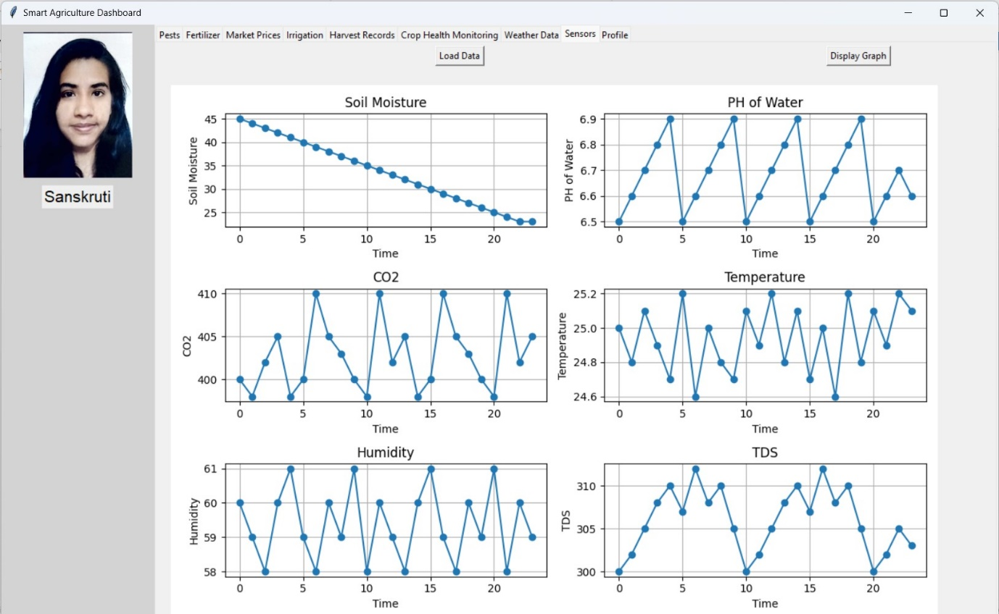

**Step 11 :** In the weather data tab, the live data of temperature, humidity and precipitation is displayed based on the Location that is provided by the user in Crop Registration Page.

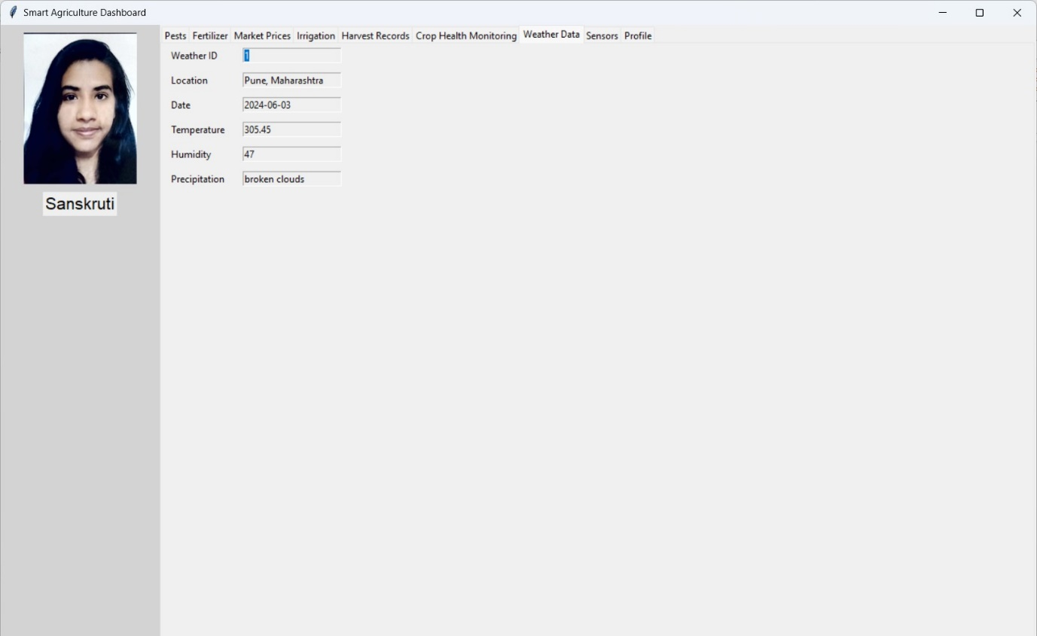

**Step 12 :** In the Crop Health Monitoring Tab, Farmer can see the health status of the Crop. If the crop is healthy, then “Healthy” will get displayed in the ‘Predicted Health Status’ field. If the crop is not healthy, then the fields that are out of range will get displayed in the “Out of Range” field and a comment would come to “Make arrangements to change out of range values” in the ‘Predicted Health Status’ field. Below is the health Status of the Unhealthy Crop.

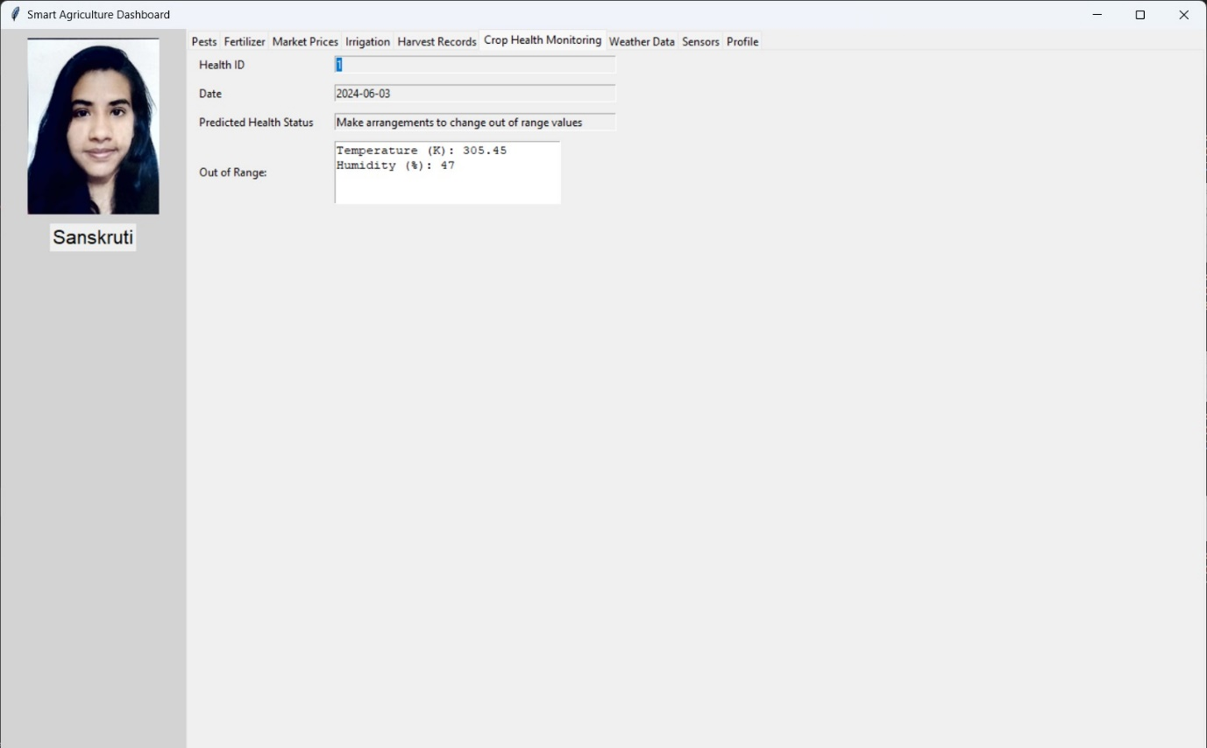

**Step 13 :** The farmer can see his/her profile and can also Logout of the software, by clicking on the “Logout” Button.

